Dr. Ruaa Elias Eshaq 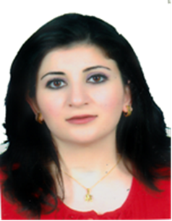

House 923, Ganjan city, Erbil, Iraq H: +9647503278669 | manhalby@yahoo.com
Skills
- lecturer, letters, Director, Publications, research, teaching
Experience
01/2006 to Current | Assistant lecturer  Honors & Distinction － Mosul  - 2014 teaching Course in medical doctor ,Erbil University.  - Four letters of Thanks & Appreciation - Director of Mosul General Hospital.  - Publications: Master research.
Education and Training
2018 | A2428179 Date of Issue. 16-8-2011 Place of Issue : Erbil-Iraq Expire Date: 13-8-2019 Present occupation: , Assistant lecturer in medical college in Mosul university

2018 | Assistant lecturer Mosul University ,Iraq

2017  2016  2015  2014 | Assistant lecturer, Mosul University, Iraq  Assistant lecture,Mosul University,Iraq  Assistant lecture,Mosul University,Iraq  Teaching ,hawler University,Iraq

2013 | M.Sc.with distinguish  medical doctor, College of Medicine, University of Mosul Past Jobs:

2013 | M.sc Doctor  Mosul University Iraq

2009 | Rotating House Officer, Mosul Hospital, Iraq

2006 | M.B. Ch. B with distinguish  University of Mosul
Languages Ilets (7 in reading,7 in speaking,5 in listeaning,5 in writting)
Activities and Honors
Reading Novel, literature , music listening , following new articles for health and fashion .
Personal Information
Personal Data: , Name: Ruaa -E-Eshaq Date of Birth: June 25, 1982 Gender: female Marital status: Married (3 Daughters)

