Curriculum Vitae

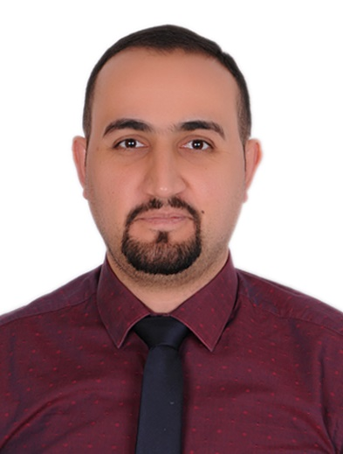
Mohanad AB
mohanad.albakr@gmail.com
Mobile no: +9647702002185

Personal Information:
Name: Mohanad
Middle name: Adnan
Surname: Al-Bakr
Date & Place of birth: 18 / 1 / 1986 & Mosul / Iraq
Gender: male
Nationality: Iraq
Marital status: married and I have one boy
Current address: Iraq / Mosul / Al-Baladiyat neighborhood

Education:
1. M.B.Ch. B (2009-2010) from Mosul College of Medicine.
2. C.A.B.M.S-EM (2018-2019) from Supreme Council of the Arab Board for Medical Specialization / Emergency Medicine.

Experiences & Courses:
- I have worked at multiple hospitals that are belonging to the Iraqi Ministry of Health at Mosul [ Al-Zahrawi Teaching Hospital, Ibn-Sina Teaching Hospital, Al-Salam Teaching Hospital] for 4 years and at Baghdad [ Baghdad Teaching Hospital, Children Welfare Teaching Hospital] for 4 years, mainly in the Emergency departments.

- I have multiple training courses for Emergency Medicine at Baghdad / Iraq, Salalah / Sultanate of Oman and at Dubai / UAE, Amman / Jordan.

- I have participated in the Emergency Medicine Conference of Arbil at 2012 & in the Emergency Medicine Conference of Dubai at 2017 (ESEM 17).

- I am a member in the Iraqi Doctors Union and Medecins sans Frontiers since 2010 and I am a founding member in Iraqi Society of Emergency Medicine (ISEM).

- I have worked at Shilan & VIN private hospital / Emergency department in Dohuk city.

- Now, I am working at the Iraqi Ministry of Higher Education and Scientific Research in the Mosul College of Medicine as (Teacher (for Emergency Medicine for 4th,5th,6th classes.

Languages:
- Arabic: mother tongue.
- English: good in speaking, reading, writing.

Skills:
- Good computer & internet skills.
- Good correspondence & communication skills.
- Ability to work under a big pressure and with a group.
- Good experiences in managing all emergent medical situations whatever the age of the patients.
- Good experiences in managing all emergent traumatic situations whatever the age of the patients.
- Good experiences in managing all critical situations whatever the age of the patients in the Intensive Care Unit (ICU).
- Excellent skills in using the Extended Focused Assessment with Sonography in Trauma(E-FAST) and Point of Care Ultrasound (POCUS).
- Good experiences in any emergent procedures, like: Thoracostomy tube, CVP line…. Etc.
- Good experiences in any minor surgical procedures, like: drainage of the abscess, suturing of the wounds.
- Good experiences in teaching the Emergency Medicine for both under & post graduate students by lectures and clinical study.

