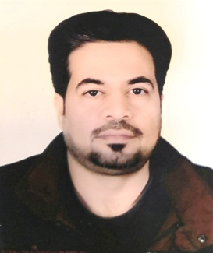**curriculum Vitae**

Name: Muthanna Abdul Razaq Hameed

Sex: male

Date of graduation :2006

Marital State: Married

Date of Birth: 1982

Place of Birth: Baghdad

Place of Residence: Mosul

Place of Work: Mosul

Address: Mosul

Telephone: 009647510397518

Nationality: Iraqi

Present occupation

Senior lecturer in orthopedic surgery\college of medicine –university of Mosul

Education:

- M.B.Ch.B in medicine and surgery in 2006 from university of Baghdad – college of medicine – Baghdad – Iraq (6 years period)

- FIBMS and a member of Iraqi board for medical specialization in orthopedics surgery in 2015

Work history:

1. Two years of rotation in Mosul hospitals from 2007-2009 as follow: (3months in pediatrics ward and emergency at Ibn Seena teaching hospital) (3months in general medicine ward and emergency at Ibn Seena teaching hospital) (3 months in cardiac care center and respiratory care center at Ibn Seena teaching hospital) (3 months in general surgery ward and emergency at Aljumhory teaching hospital) (3 months in emergency department at Aljumhory teaching hospital) (3monthes in ICU at Aljumhory teaching hospital) (3 months in gynecology and obstetrics at Mosul general hospital) (3 months in oncology department in Mosul oncology and radiation hospital)
2. Senior house officer in orthopedics surgery for one year at Aljumhory hospital (2009-2010)
3. Five years clinical attachments in orthopedics surgery as a member of Iraqi board for medial specialization.

Professional Organization

* Member of Iraqi medical association in 2006
* Member of Iraqi orthopedic association in 2010
* Member of Kurdistan medical association in2014

Honor and distinctions

* I have many letter of thanks and appreciation throughout my work period.

Other Skills

Language: Arabic is the mother tongue

Other language: English; passed TOEFL ITP with total score 520 (listing comprehension, structure and writing expression, reading comprehension)

Computer

* Get IC3 certification on 1/6/2010

Interest and Hobbies

Reading, football

Contact Information

E-mail: [muthanna_dr@yahoo.com](mailto:muthanna_dr@yahoo.com)

Phone no. 009647510397518