السيرة الذاتية
Curriculum Vitae
الدكتور محمود عبد سليمان أحميد الجميلي
Mahmood Abed Suliaman Aljumaily
استاذ – جراحة العظام والكسور Professor of orthopedic surgery
كلية الطب – جامعة الموصل College of medicine Mosul university
استشاري جراحة العظام والكسور Consultant orthopedic surgeon

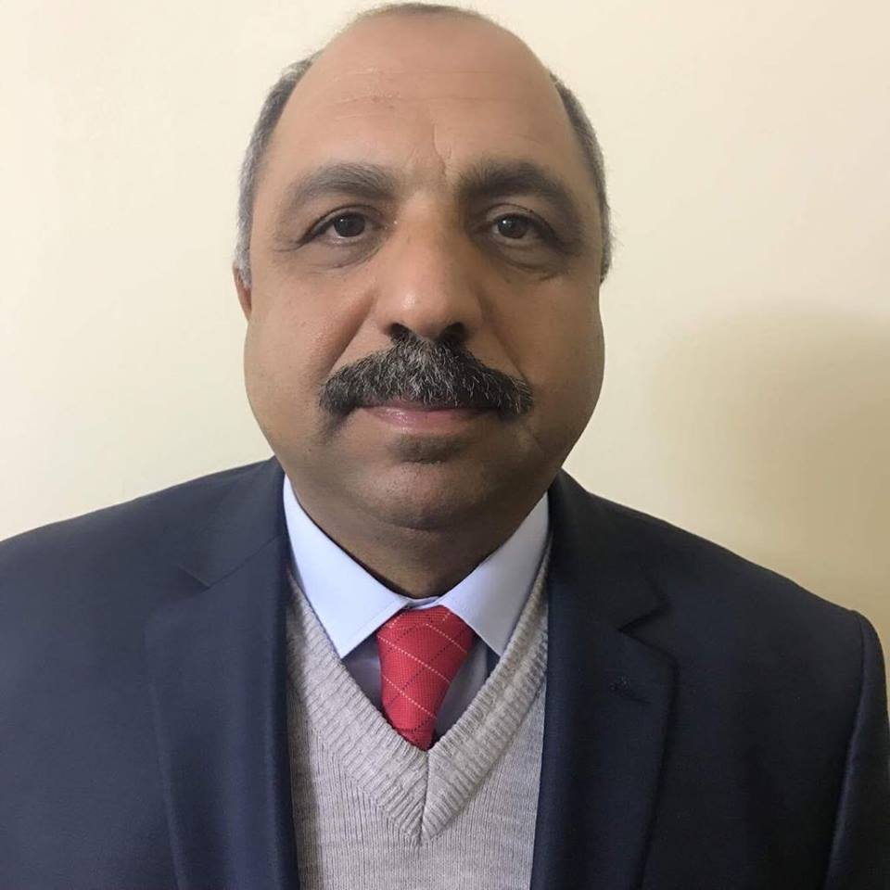
صورة شخ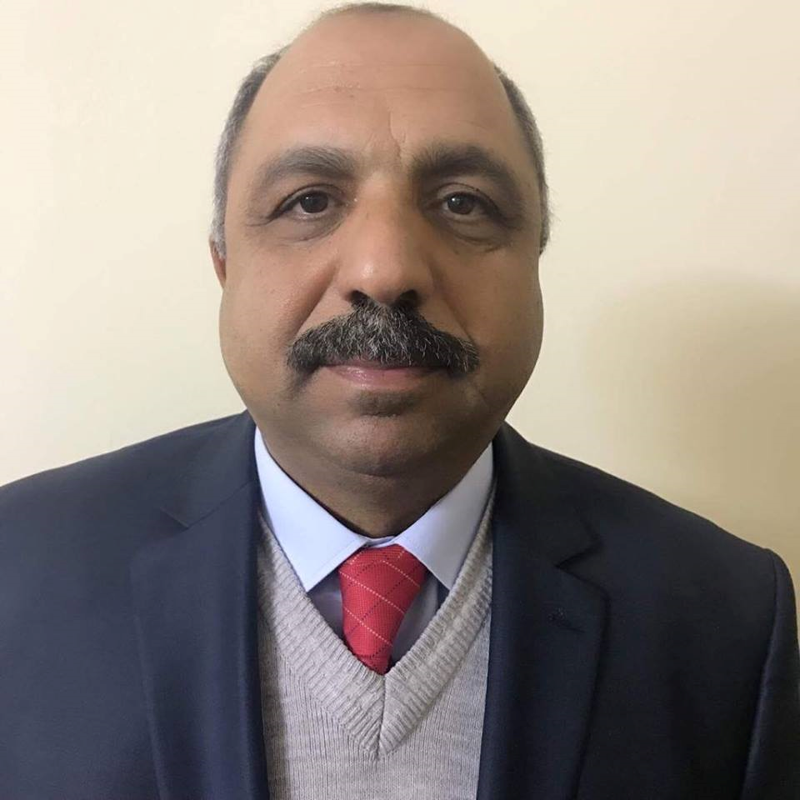صية
حديثة

Personal Information: :البيانات الشخصية

Name :  Mahmood Abed Sulaiman Aljumaily | الاسم : محمود عبد سليمان أحميد الجميلي
Date and place of Birth : Nineveh – 1959 | محل وتاريخ مسقط الرأس : نينوى –ناحية القيارة – قرية جرناف غربي : 1 / 7 / 1959.
Sex- male | الجنس : ذكر
Present address: Mosul | العنوان -الموصل – حي 30 تموز – محلة 514 – زقاق 53 – دار 9
Marital status - married | متزوج
No. of Dependents - 7 | عدد أفراد العائلة: 7
Religion-Muslim | الديانة -مسلم
First date of job 1983- 7- 16 | تاريخ أول وظيفة 1983- 7 - 16
 | المنصب الإداري الحالي ان وجد تاريخ تسلمه / /
ID No: 01426234 | رقم هوية الأحوال المدنية : 01426234
Nationality: Iraqi -Arabic | الجنسية: عراقية – عربية
E-mail : البريد الالكتروني Jumaily_ma@yahoo.com

Academic Qualificationالشهادات والمؤهلات

Certificate date / / Institute  MBChB 1983 Mosul university  Diploma in orthopedic – 1990- Baghdad university  Iraq board fellowship in orthopedic – 1992- Iraqi commission of medical specializations.  Degrees: assistant professor- 1997  Professor of orthopedic surgery College of medicine Mosul university  24/ 3 / 2011 | الشهادة: تاريخها / / الجهة المانحة:  بكالوريوس طب وجراحة— 1983 جامعة الموصل  دبلوم جراحة العظام والكسور 1990 جمعة بغداد  زمالة المجلس العلمي العراقي في جراحة العظام والمفاصل والكسور - 1992- الهيئة العراقية للاختصاصات الطبية - بغدد  اللقب العلمي - أستاذ مساعد 1997 جراحة العظام والكسور - كلية الطب – جامعة الموصل  استاذ جراحة العظام و الكسور- كلية الطب – جامعة الموصل 24 / 3 / 2011
Consultant orthopedic surgeon- ministry of health 12/ 5 / 2010 | استشاري جراحه العظام والكسور – وزارة الصحة 12 / 5 / 2010
Major specialization: orthopedic surgery | التخصص العام: جراحة العظام والمفاصل والكسور
Minor specialization : orthopedic surgery | التخصص الدقيق: جراحة العظام والمفاصل والكسور

Professional and Academic Experience الخبرات العلمية

- Supervisor of Mosul center in orthopedic in Iraqi board of medical specialization .  - examiner in orthopedic in Iraqi board of medical specialization in orthopedic  - Consultant orthopedic surgeon.  - Professor of orthopedic surgery – Mosul university | - إشراف الدراسات العليا: مشرف دراسات عليا في الهيئة العراقية للاختصاصات الطبية –جراحة العظام والمفاصل والكسور. مسئول ومشرف مركز الموصل التدريبي  ممتحن في الهيئة العراقية للاختصاصات الطبية –جراحة العظام والمفاصل والكسور.  جراح استشاري في جراحة العظام والمفاصل والكسور  - استاذ جراحة العظام والكسور في جامعة الموصل

Publications المنشورات العلمية

title |  | publisher | Volume and date
Pathological changes found during operation for Congenital Dislocation of the Hip. |  | Annals of the college of medicine, Mosul. | Vol. 22; 1996: 78-81
Squamous cell carcinoma of bone. |  | JIMA | VOL27, 1995: 178-180.
Medial longitudinal arch of foot in normal Iraqi population. |  | Accepted for publication at The medical journal of Tikrit university | Ref :041446  Date: 12-11-1997
Non-reamed intramedullary nailing in femoral shaft fractures in children. |  | Accepted for publication at The medical journal of Tikrit university | Ref :041447  Date: 12-11-1997
Primary Malignant Bone Tumors in Mosul. | Basrah journal of surgery |  | Vol – 4 –1998 : 129- 131
Complications of traditional treatment of fractures and dislocation in children | Annals of the college of medicine, Mosul. |  | Vol. 25.no.1 &2, 1999: 61-64
The centre edge angle of Wiberg of acetabulum in adult Iraqi population, a pilot study. | Annals of the college of medicine, Mosul. |  | Vol. 26, no. 1&2, 2000.
The effect of fasting on fractures healing. | Accepted for publication at The medical journal of Tikrit university |  | Ref :041602  Date: 28/ 1 /2001
Centre metaphyseal edge angle: a new measurement for determination hip subluxation and dysplasia | J. Basic Med . Sc. |  | Vol. 1. no.1&2. 2001 :46-54.
Primary Malignant Bone Tumors in Children. | Journal of the Bahrain medical society. |  | Vol. 15. no.1. January 2003 : 13-16.
Risk factors of planter fasciitis. A case control study. | Annals of the college of medicine, Mosul. |  | Vol 28, no 1, 2002: 25-30.
Primary Malignant Bone Tumors in Northern Iraq. | Journal of the Arab Board of Medical Specialization. |  | Vol. 5. no. 3. January 2003 : 24- 29.
Developmental dysplasia of the hip: the urgent need of screening program. . | Al-Zahrawi teaching hospital medical journal. |  | Vol. 1, no. 2, 2001:22-27.
Osteochondroma of scapula in children. | Al-Zahrawi teaching hospital medical journal. |  | Vol.2, no. 2&3, 2002: 14-160
Planter fasciitis: short-term result of treatment. | Al-Zahrawi teaching hospital medical journal. |  | Vol. 1, no. 4, 2001:7-10.
Wound infections in Al-Zahrawi teaching hospital. | Al-Zahrawi teaching hospital medical journal. |  | Vol. 2, no. 2&3 , 2002
Uses of thigh , inguinal, and gluteal folds for the diagnosis of developmental dysplasia of hip  -. | Annals of the college of medicine, Mosul. |  | 2004; 30: 21- 24
Tuberculosis of the Musculoskeletal System in Mosul | Presented in 2nd national tuberculosis congress. |  | 27-28/3/2oo2
Foot print : comparison between rural urban young females | Scientific Studies , –Journal of Kirkuk University |  | vol.1, No.1 ,2006: 1-6
Correlation between radiological and foot print in assessment of valgus deviation in big toe. | Kufa medical journal |  | 2007, vol 7, no 4 :24- 26
Bone function test in Meshraq sulfur fields workers. | J Edu.Sci, |  | vol-18. No-4. 2006 : 31-38.
Surgical treatment of diaphyseal fractures of forearm in children. | Annals of the college of medicine, Mosul |  | 2007; 33: 1- 7
Locally synthesized hydroxyapatite as bone graft substitute: preliminary report. | Annals of the college of medicine, Mosul |  | 2006; 32: 7- 11
Hydatid disease of pelvic bone. | JABMS |  | Vol-9, no -4; 2008  53-59
Bone function test and nutritional state in patients presented with recent fractures of femoral neck | Tikrit medical journal |  | 2008; 14 : 42- 47.
Open Osteotomy of ulna as a Model for Fracture Healing Studies in Rabbits | J Fac Med Baghdad |  | Vol.52,no 3 ,2010
Correlation between Computerized Tomography Densimetry and Histomorphometry in Assessment of Bone Healing . | J Fac Med Baghdad |  | 2010; Vol. 52, No.4
Effect of dietary supplementation on bone healing in Bisphosphonates treated rabbits | Ann. Coll. Med. Mosul |  | 2010; 36 ( 1&2): 114- 120.
Bacterial etiology of chronic osteomyelitis involving anaerobes | Ann. Coll. Med. Mosul |  | 2010; 36 ( 1&2): 106- 113.
Effect of Vitamin D, Calcium, Fluoride and Vitamin C as Dietary Supplementation on Bone Healing in Rabbits | Ann. Coll. Med. Mosul |  | 2011; 37 (1 & 2): 19-24
The Effect of Concentrated Bone Broth as a Dietary Supplementation on Bone Healing in Rabbits. | Ann. Coll. Med. Mosul |  | 2011; 37 (1 & 2): 42-47
Serum heavy metals in patients with fragments and shells of improvised explosive devices. | Ann. Coll. Med. Mosul |  | 2011; 37 (1 & 2): 8-13
Bilateral genu varus (bowlegs) at early childhood in Mosul | Ann. Coll. Med. Mosul |  | 2012; 38 (2): 87-90

Recommendation Letters عدد كتب الشكر
40 | - 40

Sources of recommendations: different مختلفة: مصادر التزكية

ختم وتوقيع رئيس العمل:

