Curriculum Vitae
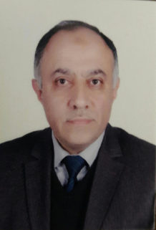

Name: Yakdhan Zuhair Al Saleem.
Date of birth: 24/10/1964.
Sex: male.
Marital status: married.
Nationality: Iraq.
Adress: Hay Al Mohandiseen,Mosul, Iraq.
Tel. 07709958577.
E- mail: alsaleem_y@yahoo.com.
Present occupation:
- Assistant professor in dept. of surgery,collage of medicine,University of mosul.
- Reporter of department of surgery since 2015.
- Reprisentor of the teaching staff in Mosul medical collage.
Degree:
- 1988 (M.B.Ch.B),collage of medicine,University of Mosul.
- 1996 (F.I.C.M.S) in orthopedic, Iraqi Commity of medical specialization.
Past jobs:
- From September 1988 – september 1990 rotating house officer in Mosul and Baghdad health directorate.
- From September 1990 – 1992 graduated doctor in villages.
- From 1992 – 1996 Cndidate of Iraqi Commity of Medical specialization at Al Jumhory teaching hospital, Mosul.
- From 1996 – 2013 Specialist in Orthopedic at Al Jumhory teaching hospital.
- From 2000 – to date, Lecturer in Dept. Of Surgery, Mosul medical Collage.continue to work as a specialist in Orthopedic surgery at Al Jumhory teaching hospital.
Professional and scientific committee:
- 1988 – To date Member,Iraqi Medical Association.
- 1997 – To date Member of Iraqi Orthopedic society.

Exprience:
Treatment of Fracures and soft tissue damage of upper and lower limbs.
Honors and Distinction:
1988 – To Date (15) letters of thanks and Appreciation.

