Curriculum vitae
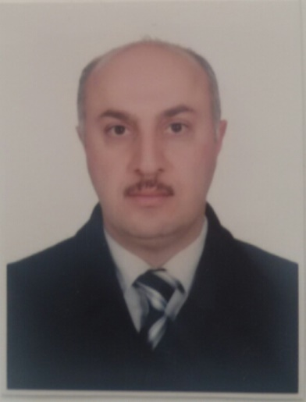

Name : Uday Hani Mohammad

Speciality : urologic surgeon

Duration of service after specialization: 13 years

Nationality: Iraqi

Marital state : married / four children

Place of birth : Dyiala / Iraq

Date of birth : 7-2-1975

Address : Iraq- Mosul

E-mail : usamerrai@gmail.com

Mobile no. : 00964-7704490925 / 00964-7517262943

QUALIFICATIONS

- Higher specialization in urology(Ph.D.)-May/2005 equivalent to British fellowship & the American board in urology.

- Jordanian board of urologic surgery(F.J.M.C.)-August/2005

- Arab board of urologic surgery(F.A.B.M.S.)- May/2006

- Member of the Royal college of surgeons - Ireland(M.R.C.S.) – june /2007

- Bachelor of surgery & medicine ( M.B.Ch.B.)

- Iraqi certificate of secondary education(1991).

EXPERIENCES

- Co-professor of urosurgery in Mosul college of medicine (from 2008 till now).
- Member of the committee of quality assurance & performance evaluation in Mosul medical college for 2 years ( 2017-2018 & 2018-2019).
- Member of the committee of accreditation of medical colleges in Mosul medical college ( 2018-2019).
- Member of the committee of rapporteurs in the surgical department (2018-2019).
- Specialist urosurgeon in the biggest Jordanian ministry of health hospitals (Al-Bashir teaching hospital &Prince Hamzeh teaching hospital) Amman- Jordan for 3 years (2006-2008).
- Specialist urosurgeon in AI-jumhoury teaching hospital & Al-salam teaching hospital in Mosul for 10 years ( from 2008 till now).
- Member of the Iraqi urology association.
- Member of the European association of urology.
- Member of the Jordanian medical association(2006– 2008) & old member of the Jordanian association of urosurgery.
- Member of the Iraqi medical association.
- 15 years practicing urodynamic studies & neurourology.
- Presentation of lectures & seminars to urology residents & the 5th year medical students in Jordan university.
- Participating in the regular meetings of the Jordanian society of urosurgeons.
- Attendance & participation in the conferences of CME & presenting lectures in the conferences held in Mosul college of medicine.
- Participating in the urologic training of the residents in Al-Salam teaching hospital.
- Attendence & participation in clinical meetings & CME lectures held in Al-salam teaching hospital & Al-jumhoury teaching hospital.
- Presentation of lectures & practical urologic training for 2 years for the undergraduate medical students of Nineveh college of medicine.
- 13 years experience in doing different & complicated urologic open surgeries in addition to different endoscopic renal & urinary tract procedures.
- Large experience in pediatric urologic surgery & managing congenital urinary abnormalities.
- Having tow researches published in the Iraqi journal of medical sciences (2013) , one research published in Baghdad medical journal (2013), one research published in Tikrit medical journal (2014) & one research published in the Saudi journal for kidney diseases & transplantation.
- Having a research which attained the title of " a pioneer research " in the gallery of Mosul University in 2014.

