Curriculum Vitae

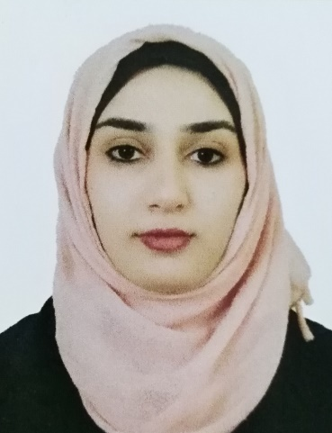
Personal Informations
Name: Zahraa Noah Fatʼhy Abdul Allah
Date and place of Birth 7/11/1984 .. Mosul
Sex:: female
Present address: Iraq \Baghdad\Tonis square.
Marital status : married
First date of job: 5/2/2008
Nationality: Iraqi
E- mail : غير مفعل
Academic Qualifications :
Certificate / date / Institute
- M.B.Ch.B. College of Medicine, University of Mosul 2007
- Friendship of Arab Board for Medical Specialization in Obstetrics & Gynecology 2018.
- Degree: Lecturer since 2018.
Major : M.B.Ch.B
Minor : Obstetrics & gynecology

Professional and Academic Experience
9th November 2007: member at Iraqi Medical Association, registration no.: 37226.
From February 2008 – February 2010: house office doctor in different branches of medicine, surgery, pediatric, obstetrics & its subspecialty at Mosul Teaching Hospitals.
From March 2010 –March 2011: registrar in obstetrics & gynecology at Baghdad Teaching Hospital in Baghdad/ Iraq. The training includes dealing with different problems in obstetrics & gynecology fields & its emergency problems, delivery room & operating theatre.
From October 2011 –March 2018 : Registrar& then senior registrar at Al-Batool Maternity & Childhood Teaching hospital & Al-Khansaa Maternity Teaching Hospital in Mosul. as apart of Residency Program in Arab board in Obstetrics & Gynecology.
From 2018 till now: lecturer of Obstetrics & Gynecology at Mosul Medical College/ Mosul University.

Participations in the International Scientific Conferences
Attending medical city conference . Baghdad . 2017
Atttending Ibn Sena University medical conference. Baghdad 2017
Attending medical city conference . Baghdad . 2018
Attending symposium organized by MSF in Mosul medical college in 2019.
Attendance in the symposium hold by obstetrics & Gynecology department/ medical college/ Mosul University held in Dec., 2017
Attending ovulation induction and IUI Workshop done by Atyaf IVF Center in Erbil at 23rd of November 2018.
P attendance in many symposiums hold by the teaching hospitals of Mosul & Mosul medical college in different topics of medicine

Publication
Thesis presented to committee of Arab Board as part of requirement of fellowship of CABOG:
Association between Chlamydial infection and preterm labour

Other Activities
Training course in teaching methods held by Mosul university in 2018

Sources of recommendation
Dr.AhmedJassim Al Hussaini/F.I.B.O.G/Ass. Professor/medical Mosul college/ MosulUniversity.
Dr. Intissar Abdul Gabbar/F.A.B.O.G/consultant OB.-Gyn./ Al Batool Maternity Teaching Hospital
Dr.Bara'a Lukman mohammed F.I.B.O.G/Lecturer/medical Mosul college/ MosulUniversity.
Dr. Raida Mohammed Al-Wazan/ F.A.B.O.G/ Ass. Professor/medical Mosul college/ MosulUniversity.
Dr. Yosra Tahir Jarjees/ F.I.B.O.G/lecturer / Ninavah medical college/ MosulUniversity.

