Curriculum Vitae

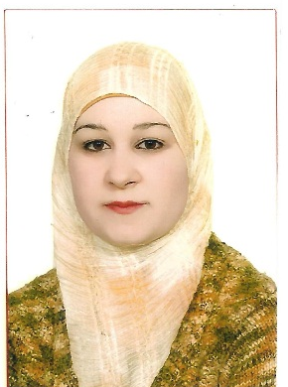

Personal Information
Name: Aseel Basim Younis Al Taee
Date and place of Birth Mosul/ Iraq -30/5/1984
Sex:: female
Present address: Iraq \Mosul\Al-BaladyateDistrict.
Marital status: Married
No. of Dependents: 4
Religion :Muslim
First date of job:26/5/2009
ID No:00304773
Nationality:Iraqi
E- mail :aseel_basim84@uomosul.edu.iq

Academic Qualifications :
Certificate / date / Institute
- M.B.Ch.B. College of Medicine, University of Mosul 2008
- Friendship of Arab Board for Medical Specialization in Obstetrics & Gynecology 2018.
Degrees:Lecturer since 2018.
Major: Obstetrics & gynecology
Minor:

Professional and Academic Experience
^{22th}November 2008: member at Iraqi Medical Association, registration no.: 38119.
From May 2009 – June 2010:Residenthouse office doctor in different branches of medicine, surgery, pediatric, obstetrics & its subspecialty at Mosul Teaching Hospitals.
FromJune2010 –August 2011: registrar in obstetrics & gynecology at Al – Batool Teaching Hospital in Mosul/ Iraq. The training includes dealing with different problems in obstetrics & gynecology fields & its emergency problems, delivery room & operating theatre.
FromOctober 2011 –March2018 : Registrar& then senior registrar at Al-Batool Maternity & Childhood Teaching hospital & Al-Khansaa Maternity Teaching Hospital in Mosul.as apart of Residency Program in Arab board in Obstetrics & Gynecology.
From September 2018 till now:Specialist in obstetrics& gynecology at Al-Khansaa Maternity &Pediatrics Teaching Hospital in Mosul.
From 2018 till now: lecturer of Obstetrics & Gynecology at Mosul Medical College/ Mosul University.

Participations in the International Scientific Conferences
Attending a training course in obstetrical emergency care held at Al-Batool Maternity Teaching Hospital 2010.
Attendance in the scientific conference of obstetrics and gynecology hold byNineveh medical college/ Nineveh University in FEBRUARY 2019 .
Attending symposium organized by MSF in Mosul medical college in 2019.
Attendance in the symposium hold by obstetrics & Gynecology department/ medical college/ Mosul University held in Dec., 2018
PreAttendance in many symposiums hold by the teaching hospitals of Mosul & Mosul medical college in different topics of medicine

Publication
Thesis presented to committee of Arab Board as part of requirement of fellowship of CABOGBladder and ureteric injury during obstetrics and gynecological procedures.

Other Activities
Training course in teaching methods and Arabic language held by Mosul university in 2018

Recommendation letters
(6) Letters of thanks from ministry of health,Nineveh health directorate, Al-Batool Maternity Hospital .

Sources of recommendation
Dr.AhmedJassim Al Hussaini/F.I.B.O.G/Ass. Professor/medical Mosul college/ MosulUniversity.
Dr. Intissar Abdul Gabbar/F.A.B.O.G/consultant OB.-Gyn./ Al Batool Maternity Teaching Hospital
Dr.Bara'a Lukman mohammedF.I.B.O.G/Lecturer/medical Mosul college/ MosulUniversity.
Dr. Raida Mohammed Al-Wazan/ F.A.B.O.G/ Ass. Professor/medical Mosul college/ MosulUniversity.

