Curriculum Vitae

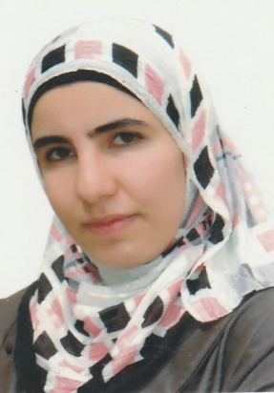
Personal Informations
Name: Ruaa Abdul jabbar Hamid Shihab Al-najmawi
Date and place of Birth Mosul/ Iraq -6/11/1983
Sex:: female
Present address: Iraq \Mosul\palatinedesecret.
Marital status: single
No. of Dependents: 7
Ligionre :Muslim
First date of job:5/2/2008
ID No:00620540
Nationality:Iraqi
E- mail :rwanshihab.raj6@uomosul.edu.iq

Academic Qualifications :
Certificate / date / Institute
- M.B.Ch.B. College of Medicine, University of Mosul 2007
- Friendship of Arab Board for Medical Specialization in Obstetrics & Gynecology 2018.
Degrees:Lecturer since 2018.
Major: Obstetrics & gynecology
Minor:

Professional and Academic Experience
9thNovember 2007: member at Iraqi Medical Association, registration no.: 37226.
From February 2008 – February 2010: house office doctor in different branches of medicine, surgery, pediatric, obstetrics & its subspecialty at Mosul Teaching Hospitals.
FromMarch 2010 –March 2011: registrar in obstetrics & gynecology at Al – Batool Teaching Hospital in Mosul/ Iraq. The training includes dealing with different problems in obstetrics & gynecology fields & its emergency problems, delivery room & operating theatre.
FromOctober 2011 –March2018 : Registrar& then senior registrar at Al-Batool Maternity & Childhood Teaching hospital & Al-Khansaa Maternity Teaching Hospital in Mosul.as apart of Residency Program in Arab board in Obstetrics & Gynecology.
From September 2018 till now:Specialist in obstetrics& gynecology at Al-Khansaa Maternity &Pediatrics Teaching Hospital in Mosul.
From 2018 till now: lecturer of Obstetrics & Gynecology at Mosul Medical College/ Mosul University.

Participations in the International Scientific Conferences
Attending a training course in obstetrical emergency care held at Al-Batool Maternity Teaching Hospital 2010.
Attendance in the scientific conference of obstetrics and gynecology hold byNineveh medical college/ Nineveh University in FEBRUARY 2019 .
Attending symposium organized by MSF in Mosul medical college in 2019.
Attendance in the symposium hold by obstetrics & Gynecology department/ medical college/ Mosul University held in Dec., 2017
Attending ovulation induction and IUI Workshop done by Atyaf IVF Center in Erbil at 23rd of November 2018.
Preattendance in many symposiums hold by the teaching hospitals of Mosul & Mosul medical college in different topics of medicine

Publication
Thesis presented to committee of Arab Board as part of requirement of fellowship of CABOG The correlation between non reassuring fetal heart rayte in labour and decrease decision delivery intervalby caesarian section

Other Activities
Training course in teaching methods and Arabic language held by Mosul university in 2018

Commendation letters
(11) Letters of thanks from ministry of health,Nineveh health directorate, Al-Batool Maternity Hospital .

Sources of recommendation
Dr.AhmedJassim Al Hussaini/F.I.B.O.G/Ass. Professor/medical Mosul college/ MosulUniversity.
Dr. Intissar Abdul Gabbar/F.A.B.O.G/consultant OB.-Gyn./ Al Batool Maternity Teaching Hospital
Dr.Bara'aLukmanmohammedF.I.B.O.G/Lecturer/medical Mosul college/ MosulUniversity.
Dr. Raida Mohammed Al-Wazan/ F.A.B.O.G/ Ass. Professor/medical Mosul college/ MosulUniversity.
Dr. YosraTahirJarjees/ F.I.B.O.G/lecturer / Ninavah medical college/ MosulUniversity.

