Corriculum vitae
Name : Bashar Shaker Mahmood 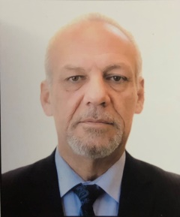
Birth date and place : Mosul 1962
Gender : Male
Residence : Mosul – Almuthanna
Mobile No. : 07511429015
E-mail : basharsm62@uomosul.edu.iq
Academic certificate : M.B.Ch.B 1984
D.M. 1990
F.I.C.M.S. 1992
Academic Title : Lecturer
Carrier progression :
Rotator doctor – Mosul hospitals – 1984-1985
District doctor – Sinjar hospital – 1986-1987
S.H.O. in neurology – Mosul teaching hospital – 1987
Post graduate candidate – 1988 – 1992
Specialist in neurology and G.M. –Mosul teaching hospital 1992
Consultant in neurology – Science &Technology univ. hospital – Sanaa/ Yemen 2005-2008
Associate prof. in medicine – College of medical sciences –Sanaa/ Yemen 2005-2008
Specialist in neurology – Ibn-cina teaching hospital – 2008
Head of neurology section –Dept. of medicine – Mosul College of Medicine 2014 till now.
Teaching Experience :
Theory &clinical teaching –arab &Iraqi board in medicine.
Theory &clinical teaching –Iraqi board in neuromedicine
Theory &clinical teaching –Iraqi board in psychiatry
Theory &clinical teaching –Diploma in rheumatology
Published work :
A paper on ( Depression in Epilepsy )
Unpublished work :
Spectrum of peripheral neuropathy in diabetes mellitus
Effect of methylcobolamine on peripheral neuropathy

