Curriculum Vita
Name: Omar Mohammed Yahya Al-Khailil
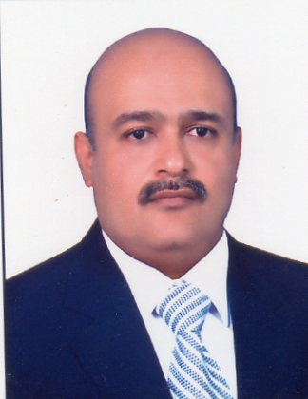
Date & Place of Birth: 26-12-1971, Mosul-Iraq
Religion: Muslim
Nationality: Iraq
Languages: Arabic & English
Computer skills:
- Using Microsoft Office ( Word, power point ,Excel)
- Using Google, Yahoo, E-mails
- Printer, Scan, Internet

Specialty: Organic chemistry
Address: Mosul-Iraq
Mobile: 07701775564
E-mail :
G-mail : dr.omarmohammed3@gmail.com,
G-mail : omermohammed@uomosul.edu.iq

Qualifications and Degrees:
B. Sc. College of Science, University of Mosul-Iraq in1993.
Post-graduate study:
M.Sc. in organic chemistry College of Science, University of Mosul-Iraq in 2005.
Ph.D. in organic chemistry College of Science, University of Mosul-Iraq in 2017.
Computer course certificate, Mosul ; Iraq in 2012.
*Assistant lecturer: in department of biochemistry, College of Medicine, University of Mosul-Iraq. 2005-2017.
*Lecturer: in department of biochemistry, College of Medicine, University of Mosul-Iraq.2017 till now.

Professional and scientific committees:
Member ship of chemist syndicate 1993
Teaching method course in College of Education ,University of Mosul, 2005
Chairman of the chemical committee in the college from 2005-2011
Chairman of the chemical committee in the college from 2017
Member of the University Committee to control the circulation of chemical, biological and radiological materials from 2017
Member of the Medical Research Centers Committee from 2018

Researches published
1- Whole blood-serum ratio compared with hemoglobin concentration , serum iron and total iron binding capacity during pregnancy
2- Ultrasound-assisted one-pot synthesis of dihydropyrimid-2-one/thiones catalyzed by zirconyl chloride hexahydrate
3- Green Synthesis and Biological Effect of Some Dihydropyrimid-2- One/Thiones
4- Theoretical Prediction of Possible Drug Treatment of COVID-19 using Coumarins Containing Chloroquine Moeity
5- Using Microwave and ultrasound to prepare of substituted Bis-acyl hydrazone Derivatives
Thanks from dean of college of medicine university of Mosul 2000
Thanks from dean of college of medicine university of Mosul 2000
Thanks from dean of college of medicine university of Mosul 2000
Thanks from dean of college of medicine university of Mosul 2001
Thanks from president of university of Mosul 2006
Thanks from dean of college of medicine university of Mosul 2007
Thanks from dean of college of medicine university of Mosul 2009
Thanks from president of university of Nineveh 2010
Thanks from dean of college of medicine university of Mosul 2012
Thanks from dean of college of medicine university of Mosul 2019
Thanks from minister of higher education 2021
Thanks from minister of higher education 2021
Thanks from president of university of Nineveh 2021
Thanks from president of university of Nineveh 2021
Thanks from dean of college of medicine university of Mosul 2021
references

Professor Dr. akram j ahmed professor and consultant in chemical pathology Akramj1948@yahoo.com
Professor dr .raad al hamdani, professor and consultant in clinical biochemistry Raadhamdani56@yahoo.com

