Curriculum vitae
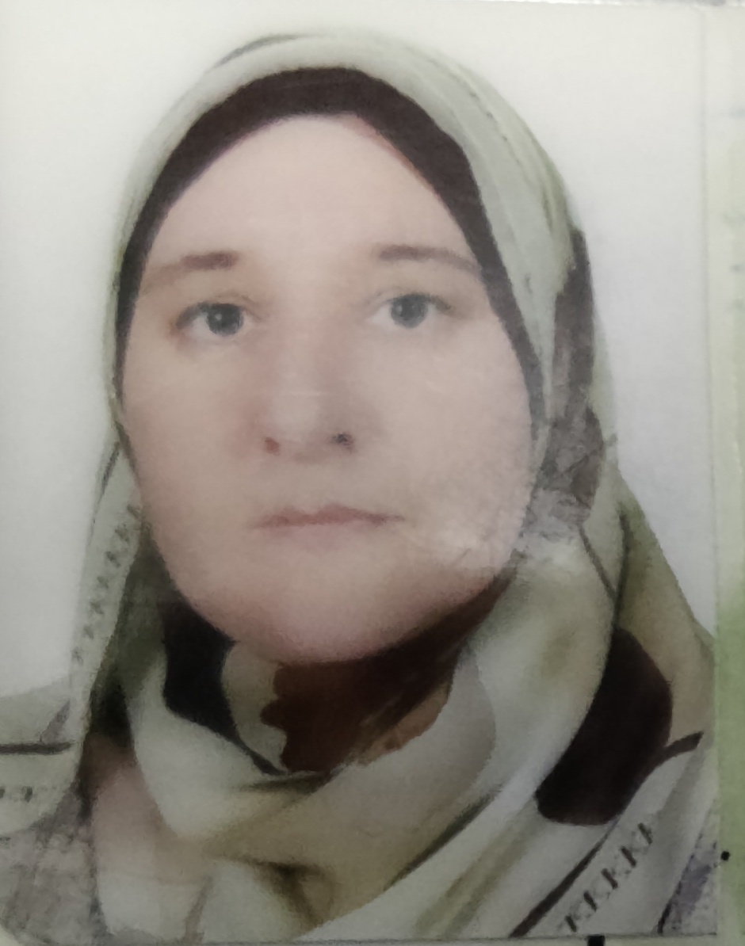
Name: Ehsan Hassan Taha
D O B: 2nd May 1975
P O B: Mosul
Social state: divorced has one son and one daughter
Nationality: Iraqi
Current address: Iraq, Mosul, Muthana Quarter, 937
Mobile 07701881088
E mail ihta_aldabagh@yahoo.com
Current position and work address lecturer in department of Biochemistry, college of Medicine, University of Mosul.
Qualification and degrees:
M. B. Ch. B: College of Medicine, University of Mosul in 1999.
MSc in Clinical Biochemistry, College of Medicine, University of Mosul in 2005
F.I.C.M.S chemical path. Iraqi Board for Medical Specialization November 2013

Professional training
Medical laboratory lecture
Practical issues
Lecturer in basic biochemistry and chemical pathology
Training MSc and PH D students

Professional courses and lectures
-Teaching method course in college of Education, University of Mosul, April 2005
-Training on laboratory technique in ibn-seena teaching hospital, Mosul, Iraq
-Workshop on polymerase chain reaction

Internships
Graduated from high school in 1993, score 97%, rank first out of 112.
M. B. Ch. B College of Medicine, University of Mosul in 1999, score 75,6%,rank 11 out of 141
MSc clinical biochemistry College of Medicine, University of Mosul in 2005, Score 78,3%
Started my internship as rotator on 28th September 1999 in Al Yamook hospital in Baghdad (ophthalmology), Ibn-seena teaching hospital in Mosul (medicine) , Al Zahrawee teaching hospital in Mosul (surgery and ER) and Ibn Alatheer hospital in Mosul(pediatric and gynecology). Rotation ended and I became Researcher Assistant on 2nd October 2001, at Department of biochemistry, College of Medicine ,University of Mosul.
Had MSc clinical biochemistry in 2005.
Assistant lecturer in biochemistry for 8 years, had F.I.C.M.S Chemical Path. Iraqi Board for Medical Specialization November 2013 became lecturer in clinical biochemistry and chemical pathology since 2013 till now.
Publications
-Ehsan Hassan Al-Dabbagh, Akram J. Ahmad.The assessment of glycemic control and renal function in ischemic heart patients
-Yosra Tahir Jarjees, Zainab Mohammed Ali Hassan, Ehsan Hassan Al Dabbagh. Freguancy of Metabolic Syndrome in Subfertile Female Population in Mosul
-Ehsan Hassan Al-dabbagh, Omar Akram Ahmed. Metabolic syndrome among patients with dyslipidemia

-Ehsan Hassan Al-dabbagh, Raad Yahya Al-Hamdani.Biochemical Risk Factors inDiabetic Patients

Honor and distinction
2009 two letters of thanks for training PHD students from department of biochemistry in college of medicine
2011 one thank from ministry of health Iraq, for hard working in hospital lab.
Languages:
Arabic (native language)
English (good proficiency)
Hebrew (ongoing courses)
Computer skills:
Microsoft office good skilling
Using different internet resources for communication and had e mail
References
Professor Dr. akram j ahmed;
Professor and consultant in chemical pathology
Akramj1948@yahoo.com

Professor Dr .raad al hamdani;p
Professor and consultant in clinical biochemistry
Raadhamdani56@yahoo.com

