Medical Curriculum Vitae
DR. Omar Saad Mahmood Al-Saegh
M.B.CH.B. - F.I.C.M.S
Department of Surgery – College of Medicine – University of Mosul

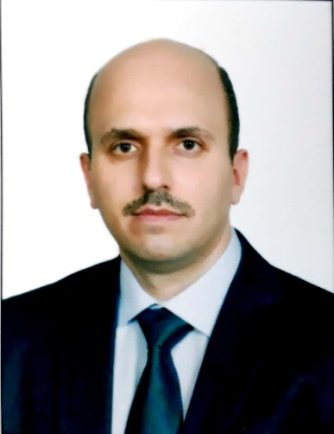
Nineveh
Iraq
omar.mahmood@uomosul.edu.iq
Education:
fellowship of the Iraqi Board for Medical Specialization in General Surgery (F.I.C.M.S.) at 21-12-2020 (Baghdad).
Bachelor degree in medicine and surgery (M.B.Ch.B.) from the College of medicine / University of Mosul at 1-7-2007.
Current position:
Lecturer in general surgery – department of surgery – college of medicine – university of Mosul since 2021 till now.
Specialist in general surgery in Al-Jumhory teaching hospital, Mosul, Iraq since 2021 till now.

Clinical experience & training
Trainee in Iraqi medical council of general surgery (board), Mosul and Baghdad centers, Iraq. 2012-2020.
Specialist in general surgery 2021-present.
Research experience
Research trainee in department of surgery, College of Medicine, University of Mosul, Mosul, Iraq. 2012 – present.
Academic appointments
Lecturer in department of Surgery, College of Medicine, University of Mosul, Mosul, Iraq. 2021 – present.
Past positions and jobs
Trainee in Iraqi medical council of general surgery (board), Mosul and Baghdad centers, Iraq. 2012-2020.
Senior House Officer in general surgery in Al-Jumhory teaching hospital, Mosul, Iraq from 2010-2012.
Junior House officer in Mosul Teaching Hospitals, Mosul, Iraq from 2008-2010.
Certifications and licensure
A license to practice general surgery as specialist surgeon, College of Medicine, University of Mosul, Mosul, Iraq. 2021- present.
Professional membership & activities
- Member of the Iraqi Medical Association since 2008 to present.
- Fellow of the Iraqi board for medical specialization.
Honors & Awards
- Two letters of thanks & appreciation from ministry of higher education and medical research 2020-2021.
- Letter of thanks & appreciation from the chairman of the Iraqi board of medical specializations in 2020.
- Fifteen letters of thanks & appreciation from Mosul teaching hospitals 2008-2020.
Publication:
1. Comparative study between sharp dissection and electro cautery dissection in incisional hernia surgery.. Annals of the College of Medicine, Mosul, 2021; 42(2): 169-176. doi: 10.33899/mmed.2020.128390.1048
Language:
Arabic, English.
References:
1. Dr. Samir I. Hasan alsaffar
Professor in the college of medicine, university of mosul.
Email: samiralsaffar@yahoo.com
2. Dr. khalaf Rasheed Jadoa
Assistant professor in the College of medicine, university of Mosul
Email: khalaf_jadoa@yahoo.com

