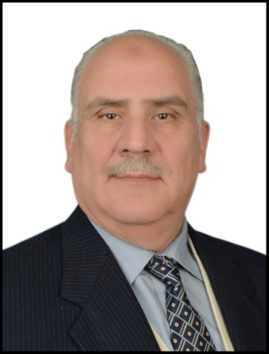
Medical Curriculum vitae
Abdulsalaam Thanoon Al Masri,
Department of surgery College of Medicine / University Of Mosul
Mosul, Iraq.
07709581451
abdulsalamthyou@uomosul.edu.iq

Education

FICMS(UROLOGY) Iraqi medical association, Baghdad 1998
MBChB university of mosul college of medicine 1988
Current position
Urological consultant 2010

Clinical experience & training
Shock wave treatment of urinary stone in children

Research experience

Academic appointments

Associated professor in department of surgery, college of medicine , Mosul , Iraq , 2007
Lecturer in department of surgery , college of medicine , Mosul, Iraq …..2000

Past positions and jobs

1. From Jun. 1988 – Dec. 1989 Medical army officer, medical army services.
2. From Dec. 1989 –Feb. 1992 rotating house officer at Kirkuk health directorate, Kirkuk.
3. From Feb. 1992 – Feb. 1993 Sinjar and Sheikhan general hospital.
4. From Feb. 1993 – Oct. 1993 senior house officer at Al Salaam teaching hospital, Nineveh health directorate, Mosul.
5. From Oct. 1993 – June 1998 Candidate of Iraqi Commission for Medical Specialization at Al Jomhoury teaching hospital, Mosul.
6. From Jun. 1998 – Dec. 1998 Specialist in urology at Al Jomhoury teaching hospital, Nineveh health directorate, Mosul.
7. From Dec. 1998 – Jan. 2000 Specialist in urology at Kirkuk health directorate, Kirkuk.
8. From Jan. 2000- to date Lecturer in the college of medicine, University of Mosul and Specialist in urology at Al Jomhoury teaching hospital, Mosul.

Certifications and licensure
• 1988 – To date Member, Iraqi Medical Association.
• 2000 – To date Member of Iraqi urological society.

Professional membership & activities
. • 1988 – To date Member, Iraqi Medical Association.
• 2000 – To date Member of Iraqi urological society.
Honors & Awards
1989 - To date (27) Letters of thanks & Appreciation from Nineveh and Kirkuk health directorates, Ministry of health and Mosul college of medicine & Nineveh college of medicine, university of Mosul
Publications
1. Renal tumor a clinico-pathological study in Mosul a retrospective study.
2. Testicular tumors in Mosul province.
3. Extracorporeal Shock Wave Lithotripsy for pediatric ureteral stones.
4. Early experience of extracorporeal shock wave lithotripsy for urolithiasis in children in Mosul
5. Epididymorchitis a review of 85 cases in Mosul.
6. Chronic testicular pain a clinico-pathological study.
7. Vesical stone on partially migrated IUCD.
8. Vesical stone on absorbable suture.
9. Congenital inguinal abnormality in children.
10. The color Doppler ultrasound in evaluation of infertile men.
11.surgical training of undergraduate students at Mosul college of medicine ;a preliminary evaluation .2021

Languages
Arabic, English

Interest & hobbies
Reading , calligraphy , painting

Referees
Chair man of department of surgery dean of college of medicine

ملاحظة
هذه سيرة ذاتية علمية بحتة ولهذا لا يذكر هنا الحالة الاجتماعية ولا الديانة ولا العشيرة والاثنية ولا القومية
الامثلة باللون الاحمر تحذف وتكتب المعلومات باللون الاسود بدون
bold

