Medical Curriculum Vitae

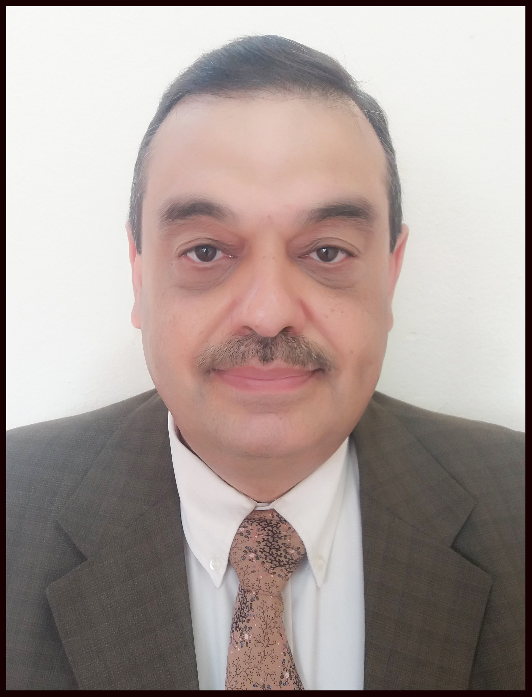

صورة شخصية
حديثة

Personal Information: ة

Name :Karam Kamal Younus Sharif Bak M.D , FICMS, CABS
Date and place of Birth :1/12/1966, Mosul, Iraq
Sex: Male
Present address: Dept. Of Surgery, College of Medicine / University of Mosul
City/ Country: Mosul/ Iraq
Nationality: Iraqi
E-mail : karamkyounis@umosul.edu.iq

Academic Qualificationا

- (C.A.B.S) Arab Board for Surgical Specializations, Arab Council for Medical Specialties, 2000 Damascus.
- (F.I.C.M.S) Iraqi Board for Surgical Specializations. 1999 ,Baghdad,Iraq.
- (M B Ch B) College of Medicine, 1990 University of Mosul ranking third in graduation.
Current position Assistant professor of Surgery at Dept of surgery Mosul college of since 25/11/2008
Consultant surgeon since 2013

Clinical experience and training
- Consultant surgeon at year 2013
- Specialist surgeon at year 1999
- Trainee in general surgery at Mosul center All Jamhoori hospital since 1992
Professional and Academic appointments

- 1999- 2008 lecturer at the department of surgery in Mosul college of medicine
- 2008-till now Assistant professor of surgery,department of surgery ,Mosul medical college.
- 2009- 2014 convener of the department of surgery

- Teaching & lecturing surgery in the college of medicine.
- Treating & operating on patients at Al-Jamhoori teaching hospital that is affiliated to the college Of Medicine
- Supervising postgraduate students in the Iraqi board of surgery
  - till now member of Iraqi Medical Association
- .2003 till now member of Mosul Breast Clinic.
- Member of different committees in the college of Medicine

Past positions and jobs
- Consultant surgeon2013
- Specialist surgeon1999
- Senior House Officer and trainee in Iraqi board for surgery center ( general Surgery )in Al-Jumhoori teaching Hospital- Mosul –1994-1999
- General practitioner in primary health care center in Mosul city/ Iraq1992 to 1993
- Junior House officer or Resident Doctor in different dept and branches in Mosul hospitals 1990 to 1992

Certifications and licensure
- A license to practice general surgery, FICMS, Baghdad, Iraq year 1999
- CABS Demascus at year 2000

Participations in the International Scientific Conferences
- Participations in local & international conferences in laparoscopic surgery(Baurdeaux, France 2006).
- Training in surgical oncology at Rajeev Gandhi Cancer Institute in Delhi, India 2010
Professional membership & activities
- Member of Iraqi Medical Association 1990-
- Fellow of Iraqi surgical council
- Member of Iraqi teachers union/ Mosul branch

Honors & Awards
Commendation Letters ر
1. Dean of the Faculty of Medicine of Mosul 1999
2-Deanship of the Faculty of Medicine of Mosul 2000
3-Deanship of the Faculty of Medicine of Mosul 2002
4-Dean of the Faculty of Medicine of Mosul 2004
5-Presidency of University Mosul 1999
6-Dean of Faculty of medicine, Ninawa 2004
7-Dean of Faculty of medicine, Ninawa 2005
8- Dean of the Faculty of Medicine of Mosul 2012
3 letter of thanks & appreciation from Mosul teaching hospitals 2010-2012
3 letter of thanks & appreciation from Minister of higher education and scientific research 2020-2021
4 letters of thanks from president of University of Mosul 2020- 2021
Voluntary/work experience
Participant in the surgery team of MSF France in Mosul in 2016
Workshops , symposiums & conferences
- Lecturer in the 1st and 2nd laparoscopic conferences at 2012 and 2013 in the Mosul college of Medicine
- Participant in the workshop of laparoscopic surger in Burdeaux France at 2006
PUBLICATIONS
- Osteoma of the tongue: case report & review of literature
( published مجلة علوم الرافدين العدد الاول المجلد الخامس عشر2004)
- Thyroglossal duct anomalies:10 years review Annals of the college of Medicine Mosul2003;15(2) (
- A rare presentation of pneumatocele: case report & review of literature published in Bahrain Med Bull 2002;24(4):
- The profile of breast diseases in patients with mastalgia: Audit of breast clinic in Mosul. (Published in Annals of the college of Medicine Mosul2008;34(2)
- Spleen- sparing surgical treatment for hydatidosis of the spleen Tikrit Medical Journal 2008;14(2)
- Compound Volvulus in pregnancy: a case report and review of literature:journal of arab board of medical specializations 2009; 10 (1): 66-68
7-Pneumatosis Cystoides Intestinalis Associated With Pyloric Stenosis: A Clinical Case Report & Review Of Literatures Iraqi Med J 2011;57(2):176-179.
8- Feasibility of percutaneous needle aspiration
for the treatment of breast abscesses (Ann Coll Med Mosul 2013; 39 (1): 65-69).
9-Evaluation of clinical parameters that predict difficulties during laparoscopic cholecystectomy IPMJ2013;12 (2):175-180,
10-Cholecystectomy for Asymptomatic gall stone: re-evaluation after the introduction of laparoscopic cholecystectomy proceeding of 11th scientific conference and 3rd laparoscopic surgery conference May 6-7th College of Medicine ,University of Mosul page 45-50
11_Objective structured clinical examination for undergraduate surgery finals in the college if medicine,university of Mosul Annals of college of medicine university of Mosul
Languages
English and Arabic
- Trainee in the workshop in Delhi ..Rjeef Ghandi cancer institute and research
Interest & hobbies
Reading & swimming,
Referees
- Dean of college of Medicine professor Basil Saeed
- Head of Department of surgery professor Sameer Alsaffar

