Dr.Bassam Khalid Abed Al-kozee
contact |  | 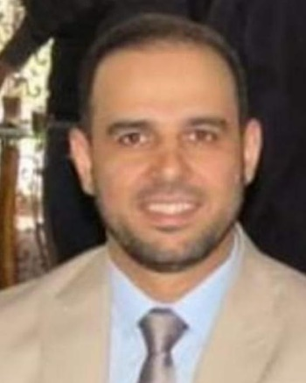  Work Address:  Department of surgery, Mosul medical college - University of Mosul  Pediatric surgery center at AL-Kansa’a teaching hospital Mosul, Iraq  Email: drbassam1812@yahoo.com  Mob: 009647701675571
Present Occupation |  | Specialist pediatric surgeon, AL-Kansa’a teaching hospital Mosul, Iraq  Lecturer in Department of surgery, Mosul medical college - University of Mosul.  Vice of the Doctors syndicate of Nineveh  Chief of Rafaah foundation of relief and development  Trainer in Arabic board of pediatric surgery
Education |  | 2010 F.I.C.S (fellowship of Iraqi commission of pediatric surgery) the Iraqi board for medical specialization.  2000 Medicinae Baccalaureus, Chirurgiae Baccalaureus (MB ChB) / College of Medicine- University of Mosul, Mosul, IRAQ. Graduation grade: Very good (80.03%) rank third out of 174  1994 Baccalaureate Examination: Excellence with score of (98.5%), rank 5th among all Iraqi students
medical training |  | 2018 diploma in minimal invasive surgery from world laparoscopy hospital, india.  2013 fellowship in pediatric urology, Aichi children’s health and medical Centre/ Nagoya, Japan  Pediatric surgery training from july2004 to sep.2010 at al-kansa’a teaching hospital, Mosul, Iraq  Senior house officer: general surgery training from apr.2002-july2004 at al-zahrawi teaching hospital, Mosul, Iraq.  Gyn. And obstetrics from jan.2002-apr.2002  Pediatrics from oct.2001-jan.2002  General surgery from apr.2001-oct.2001  Medicine from oct.2000-apr.2001  Junior house officer 2000-2002 At Mosul teaching hospitals
MEMBERSHIPS |  | Member of the Iraqi medical association  Member of the Iraqi surgeons’ society  Member of the Japanese pediatric urology association.  Member of the Islamic medical association in Iraq  Member of the Iraqi league for medical professions  Member of human relief foundation (HRF) in Mosul  The chief of Rafah foundation
APPRECIATIONS |  | 13 Appreciation Plaque (for succeeding unique surgical procedures), al-kansa’a hospital, Mosul, Iraq  Appreciation Plaque (for succeeding a unique surgical procedure first done in Nineveh), Nineveh Governorate Office  Appreciation Plaque (for doing hundreds of surgical procedures for the citizen of  Al-hamdania), Al-hamdania hospital  Appreciation Plaque (for supporting the health system with medical equipment needed during covid-19 pandemic), Al-Salam hospital, Mosul, Iraq
Activities |  | 2020 attending cleft lip and palate workshop in cairo / Egypt  2019 attending hypoelxe 5 workshop in Alexandria / egypt and global pediatric conference in cairo at the same period.  2019 prepare a hypospadias workshop in 2 days: papers presentation and live surgery and also giving a presentation about female duplex urethra, NMC Medical Conference‎, Mosul, Iraq  2018 attending a pediatric urology conference in New Delhi  2018 2 weeks training at world laparscopy hospital in New Delhi  2010- 2018 yearly giving a topic about pediatric surgery advances in the yearly symposium of department of surgery mosul medical college.  2012 pediatric surgery conference in Doha Qatar  2011 hypospadias conference and present a paper on outcome of TIP technique in circumcised hypospadias  2011 Istanbul workshop in hypospadias and clinical attachment at Jarah Basha hospital with dr Halluk pediatric urology  2011 pediatric surgical urology workshop  2010 attendance a training in gastrointestinal endoscopy in Ibn-Seena teaching hospital for one month  In addition to attending and shearing in many worksops,conferences and symposiums in Baghdad, Erbil ,Mosul and Tikrit.
Publications |  | Transanal pull through for 40 cases with hirschsprung disease  Outcome of tip technique in circumcised hypospadias  Tunica vaginalis flap usage in complicated hypospadias and redo cases.  Tubularized preputial free graft one stage repair for proximal hypospadias(in progress)  Laparoscopic recurrent pediatric inguinal hernia repair using Takihara needle (in progress)
Recommendations |  | Prof. Abdulrahman Abdulazeez (FRCS, member of BAPS)  Consultant general and pediatric surgeon  Prof. at Mosul university, medical college Sulaimanzme@yahoo.com  Prof. Kais M. Al-wattar (FRCS, member of BAPS)  Consultant general and pediatric surgeon  Prof. at Erbid pediatric surgery center, Jordan

