Medical Curriculum Vitae
DR. Saher Habeeb Qaryaqos Toma AL Banaa
M.B.CH.B. - F.I.B.M.S
Department of Surgery – College of Medicine – University of Mosul

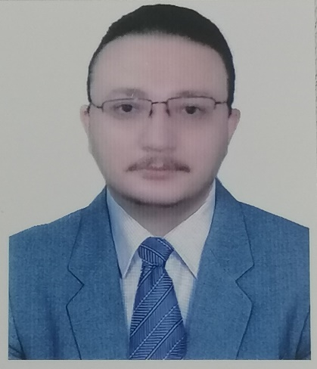
Nineveh
Iraq
07701781075
saherhabeebortho@uomosul.edu.iq
Education:
Fellowship of Iraqi Medical specialization committee in orthopedic surgery (F.I.B.M.S.) at 12-11- 2018 (Baghdad)
Graduation; M.B.CH.B in grade very good and the third of 115 graduates from university of Mosul – college of medicine at 5-8-2010
Current position:
Lecturer in orthopedic surgery – department of surgery – college of medicine – university of Mosul since 2018 till now

Previous jobs:
- Five years as trainee in orthopedic surgery in Baghdad , Erbil in different hospitals as part of Iraqi board of medical specialization 2013-2018
- One and half year as orthopedic senior house officer at al Jamhori hospital –Nineveh at 2012-2013
- Three months in primary health care center at al Namrood health care center- Nineveh at 2012
- One year resident doctor at al Jamhori teaching hospital and al Hamdannyya hospital- Nineveh at 2010-2011
Professional memberships:
*Member of the quality assurance & university performance committee of surgical branch of Mosul medical college 2021 till now
*Member of the student card committee 2019-2020
*Fellow of the Iraqi orthopedic society 2018
*Member of the Iraqi medical association 2010
Thanks and letters:
*Two letters of thanks from ministry of higher education and medical research 2020-2021
*Two letters of thanks from Mosul medical college 2020-2021
*Concert honoring for the first Iraqi graduates medical students (M.B.CH.B) at 2010
Participation:
*Speaker in annual meeting of Surgical Department- College of Medicine – University of Mosul at 2021 on guideline in treatment of knee osteoarthritis
*Speaker in 14th international scientific conference of Mustansiriyah – college of medicine- Baghdad at 2019 on distal radius fractures and treatments
Publication:
1- Professor Mahmood A Aljumaily, Yakdhan Al Saleem, Saher H Albanaa: Intertrochanteric Femoral Neck Fractures Treated by External Fixation. (Ann coll Med Mosul 2021; 43(1):16-20).
Language:
Arabic, English and Assyrian
Interest and hobbies:
Reading and sports
References:
College of medicine, university of Mosul
Iraqi Medical Association, Mosul branch

