Name : Shaimaa Muyasser Nayif Al-Faris
Curiculum Vita
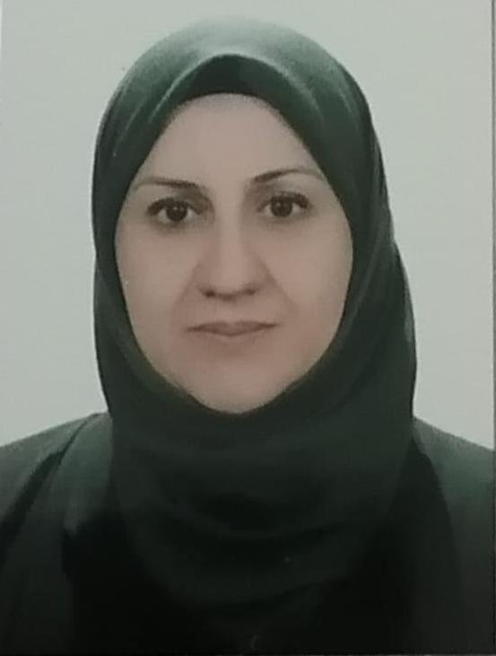
Gender : Female
D O B : 3 May 1977
Place of birth : Mosul
Social state : Married
Nationality : Iraqi
Current address : Mosul, Al-Tayaran Internship :
Bachelor of Science, University of Mosul for the academic year 1998-1999 with Good grade
MSc Biochemistry, College of Science, University of Mosul , September 2022 , Iraq, Score 87%
Assistant teacher in 10/5/2022, Department of Biochemistry ,College of Medicine ,University of Mosul.
Current position and work address : Lecturer in Department of Biochemistry ,College of Medicine, University of Mosul.
Qualification and degree : B.Sc. College of science ,University of Mosul 1999 , Mosul, Iraq
MSc Biochemistry, College of Science, University of Mosul , September 2022, Iraq.
E mail : shaymaa.nayf@uomosul.edu.iq
Langueges : Arabic native language, English good proficiency.
Professional training
Lecturer in basic theoretical lectures.
Lecturer in practical medical laboratories.
Computer skills :
Good skill using Microsoft Office system.
Good skill using Microsoft Excel system.
Good skill using the PowerPoint system.
Using of different means of communication Internet and E-mail
Honor and distinction
4 thanks

References :
- Mikkelsen S.R., BioanalyticalChemistry, 2nd Ed., Wiley&Sons,Inc.,Hoboken,NewJersey (2016).
- Piotte, M., Walenta, G., Gauthier, M. C., Caspar, J. C., Füllmann, T. Characterisation of Gypsum, Global Gypsum Magazine, September 2002, 20-24.
- Christian G.D.,(2014). Analytical chemistry", John Wiley and sons , USA, 6th Edn. .
- Walenta, G., Füllmann, T., Gimenez, M. et al.: Quantitative Rietveld Analysis of Cement and Clinker, International Cement Review, June 2001

