CURRICULUM VITAE “C.V.”

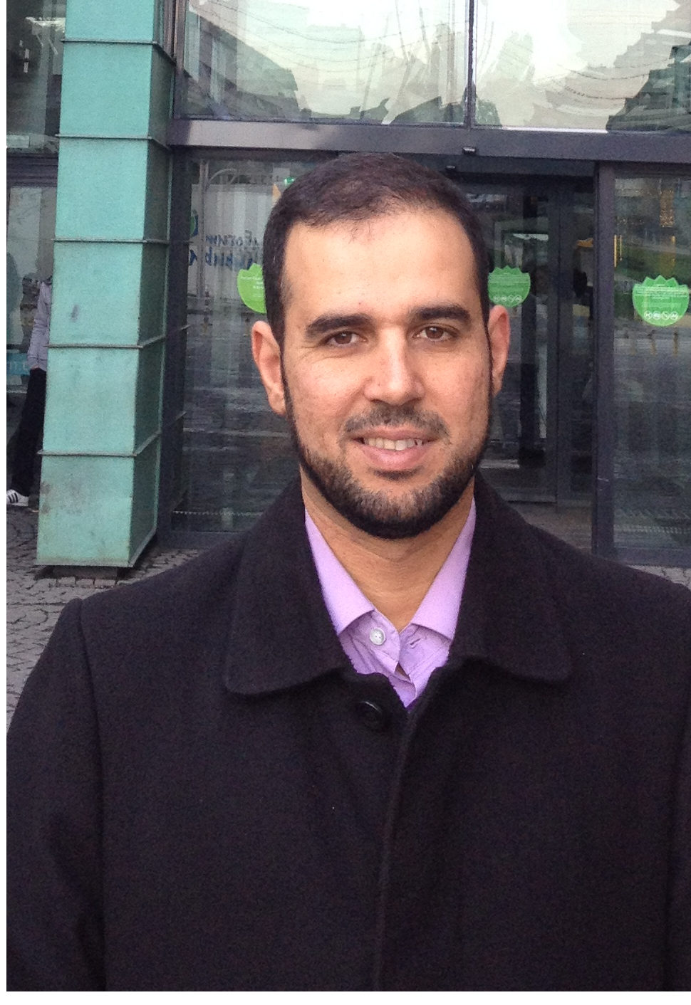 | Name: Dr Bassam Khalid Abed Al-kozee  Birth place & date: Mosul, Iraq, 18th December 1976  Nationality: Iraqi  Religion: Muslim
Work Address:
Department of surgery, medical college, university of Mosul, Mosul, Iraq
Pediatric surgery center at AL-Kansa’a teaching hospital Mosul , Iraq

Email: drbassam1812@yahoo.com
Mob: 009647701675571

Present Occupation

Specialist pediatric surgeon, AL-Kansa’a teaching hospital Mosul , Iraq
Lecturer in Department of surgery, Mosul medical college / University of Mosul.
Education:
Primary school 1982-1988
Secondary & high school 1988-1994 (Excellent score 98.5%) rank 5th among all Iraqi students

Medical college at 1994-2000
Mosul university Graduation grade
Very good
(80.03%) Rank third out of 174

Junior house officer 2000-2002
At Mosul teaching hospitals
Medicine from Oct.2000-Apr.2001
General surgery from apr.2001-Oct.2001
Pediatrics from Oct.2001-Jan.2002
Gyn.and Obstetrics from Jan 2002-apr.2002

Senior house officer: General surgery training from Apr 2002-July2004 at AL-Zahrawi teaching hospital
Pediatric surgery training from july2004 to sep 2010 at AL-Kansa’a teaching hospital

Degress (qualification)

2010 F.I.C.S (fellowship of Iraqi commission of pediatric surgery ) the Iraqi board for medical specialization.
2000 MB.CH. B. College of Medicine, University of Mosul

Activates:
2007 I attended a training course in advanced life support in Syria.
2008 I participate a workshop in laparoscopic surgery at AL-Kansa’a teaching hospital.

2010 I attended a training in gastrointestinal endoscopy in Ibn Seena teaching hospital for one month
2011 pediatric surgical urology workshop
2013 istanbul workshop in hypospadias and clinical attachment at Jarah Basha hospital with dr Halluk pediatric urology….
2013 Three months fellowship at Nagoya Japan in pediatric urology…
2018 diploma in minimal invasive surgery from world laparoscopy hospital,india.
Experience :
Accumulated experience and knowledge in the field of pediatric surgery , including : neonatal surgery ,pediatric emergency, pediatric urology, pediatric laparoscopy , elective surgery and endoscopies.

Publications :
- transanal pull through for 28 cases with hirschsprung disease
- outcome of tip technique in circumcised hypospadias (in process)
- tunica vaginalis flap usage in complicated hypospadias.
- Ventral flap in tubularised incised plate technique in hypospadias repair.
- Laparoscopic recurrent pediatric inguinal hernia repair using Takihara needle(in progress)
Referees :

- Member of the Iraqi medical association
- Member of the Iraqi surgeons society
- Member of the Islamic medical association in Iraq
- Member of the Iraqi league for medical professions
- Member of human relief foundation (HRF) in Mosul

Recommendations :

- Prof . Abdulrahman Abdulazeez (FRCS, member of BAPS)
Consultant general and pediatric surgeon
Prof . at Mosul university , medical college Sulaimanzme@yahoo.com

- Prof . Kais M. Al-wattar (FRCS , member of BAPS )
Consultant general and pediatric surgeon
Prof . at Erbid pediatric surgery center , Jordan

