Curriculum vita
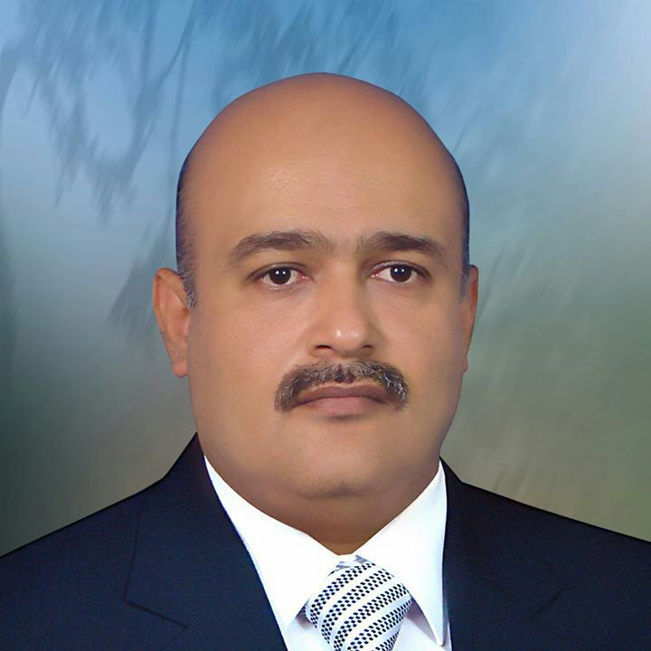
Name: Omar Mohammed Yahya Najim Al-Khalil
D O B: 26 December 1971
P O B: Mosul
Social state: Married have one son and three daughters
Nationality: Iraqi
Passport no.
Current address: Mosul, Muhandisin
Mobile : 07701775564
E mail: dr.omarmohammed3@gmial.com
Current position and work address: Lecturer in Department of Biochemistry ,College of Medicine, University of Mosul.
Qualification and degree:
B.Sc. College of science ,University of Mosul July 1993 , Mosul , Iraq
MSc Organic Chemistry , College of Science , University of Mosul , May 2005 , Iraq
Ph.D. Organic Chemistry College of Science, University of Mosul , October 2017 , Iraq
Professional training:
Training in private Medical laboratory for five years
Lecturer in Organic Chemistry
Training MSc and PH D students
Professional courses and lectures
Teaching method course in college of education ,university of mosul April 2005
Internship
Graduated from high school in 1989 , score 76.6% , in the scientific branch.
Bachelor of Science, University of Mosul for the academic year 1992-1993 with average grade .
M.Sc. Organic , College of Science , University of Mosul , May 2005 , Iraq
Ph.D. Organic , College of Science , University of Mosul , October 2017 , Iraq

Honor and distinction
2000: one thanks from the Deam of Mosul , College of Mosul.
2000: one thanks from the Deam of Mosul , College of Mosul.
2000: one thanks from the Deam of Mosul , College of Mosul.
2001: one thanks from the Deam of Mosul , College of Mosul.
2006: one thanks from the President of Mosul Universitry .
2007: one thanks from the Deam of Mosul , College of Mosul.
2009: one thanks from the Deam of Mosul , College of Mosul.
2010: one thanks from the President of Mosul Universitry .
2010: one thanks from the Deam of Mosul , College of Mosul.
2012: one thanks from the Deam of Mosul , College of Mosul.
2019: one thanks from the Deam of Mosul , College of Mosul.
Langueges:
Arabic native language
English good proficiency
Computer skills:
Microsoft office good skilling
Using different internet resources for communication and had e mail
References:
Professor Dr. akram j ahmed professor and consultant in chemical pathology
Akramj1948@yahoo.com
Professor dr .raad al hamdani, professor and consultant in clinical biochemistry
Raadhamdani56@yahoo.com

