Curriculum vitae
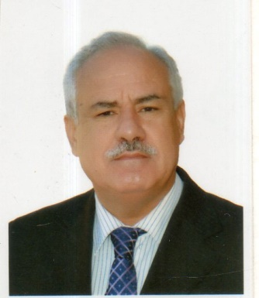
Name: Hazim Allawi Mohammed
Sex: Male
Date of birth: March 1961
Nationality: Iraqi
Marital status: Married with four children
Present position and working address: Head &lecturing in Clinical Biochemistry Department of Biochemistry College of Medicine, College of Medicine ,University of Mosul ,Mosul ,Iraq.
Academic qualifications:
1.MB.,Ch., B .College of Medicine, University of Mosul , Mosul ,Iraq graduated in 1986 grade good rank 11 out of 185 students
2.MSc in Clinical Biochemistry College of Medicine University of Mosul ,Mosul , Iraq 1993
3.PhD in Clinical Biochemistry , College of Medicine , University of Mosul, Mosul, Iraq, 2010
Professional experiences:
- Rotation at Mosul Teaching Hospital working in Medicine ,Surgery ,Pediatrics, Gynecology from July 1986-oct 1987.
- Demonstrator in Department of Physiology, College of Medicine, University of Mosul from Jan 1988- Jan 1991.
- Demonstrator in Biochemistry , Department of Biochemistry, College of Medicine, University of Medicine from Jan 1991 –Oct 1991.
- Postgraduate student for MSc in Clinical Biochemistry , Department of Biochemistry, College of Medicine.
University of Mosul from Oct 1991-dec 1993.
- Assistant lecturer in Clinical Biochemistry, Department of Biochemistry College of medicine, Mosul Iraq Jan 1994-Dec 1999.
- Lecturer in Clinical Biochemistry, Department of Biochemistry ,College of Medicine, University of Mosul , Mosul Iraq from Dec 1999-2011.
- Postgraduate student for PhD Clinical Biochemistry , Department of Biochemistry ,College of Medicine, University of Mosul.
- Assistant Professor in Clinical Biochemistry from 2011 till now.
- Head of Department of Biochemistry ,College of Medicine ,University of Mosul, Jan 2018 till now.
Publications
1.Mohammed H A .Serum urea ,Creatinine Clearance as indices of renal functions, MSc thesis , University of Mosul ,College of Medicine 1993
2.Mohammed HA .Predicted creatinine clearance in subjects with normal renal function. Annals of the College of Medicine ,Mosul ,1999;25:41-44
3.Ibrahim YS ,Mohammed HA ,Abed ZA. Acroderatitis enteropathica in northern Iraq. Annals of the college of medicine ,Mosul 2000;26:11-14.
4.Mohammed HA, Kalel HA ,Aziz AA , Mula Abed WS. Effect of Ramadan fasting on glycemic control in Iraqi diabetic . Annals of the college of medicine ,Mosul 2000 ;26:29-34.
5.Mula –Abed WS ,Mohammed HA, Aziz AA. Serum fructoseamine as an index of glycated protein in patients with chronic renal failure on hemodialysis .Annals of the College of Medicine , Mosul 2001;26:
6.Mohammed HA, Ahmed AJ, age and sex related reference range for creatinine clearance in Mosul province. annals of the college of medicine, Mosul(submitted for publication)
7.Mohammed HA, Al hamdani RY ,Al Habbal MJ . predicted creatinine clearance in patients with impaired renal function . Annals of the college of medicine, Mosul (submitted for publication)
References:
1-Prof. Akram J Ahmed ,Department of Biochemistry , College of Medicine , Mosul, Iraq.
2-Prof.Waad Allah S Mula Abed ,Department of Biochemistry , College of Medicine , Mosul, Iraq.
3-Dr. Nazar M Quabh ,Department of Medicine , College of Medicine, Mosul, Iraq.

