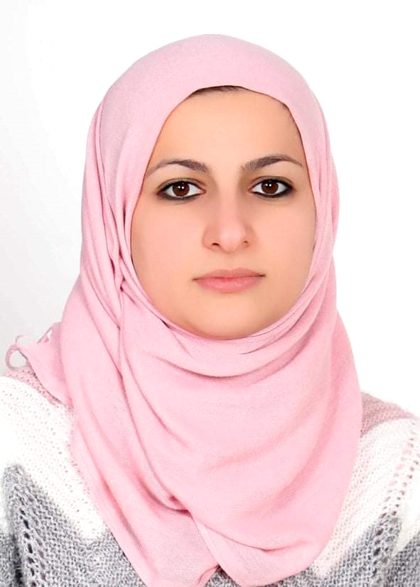
Curriculum Vitae
Name: Raghad Khalil Ibraheem Al sarraf
Gender: female
Date of birth: 15th, Jan, 1983
Place of birth: Mosul, Iraq
Nationality: Iraqi
Social state: married
Mobile No.: +96407701706305
Place of work: Department of Biochemistry/ College of Medicine / University of Mosul, Mosul, Iraq
Current address of work: Assistance lecturer, Department of Biochemistry/ College of Medicine / University of Mosul, Mosul, Iraq
E-mail Address: raghadalsaraf@gmail.com
raghadki@uomosul.edu.iq
Researchgate: https://www.researchgate.net/profile/Raghad_ HYPERLINK "https://www.researchgate.net/profile/Raghad_Alsaraf"Alsaraf
GoogleScholar:
https://scholar.google.com/citations?view_op=new_profile&hl=en Raghad+Alsaraf#

Academic Degrees :
- M.Sc. (clinical biochemistry), College of Medicine, University of Mosul, Iraq, Jun 2012, Grade: Very good
- M.B.Ch.B, College of Medicine, University of Mosul, Iraq (2000-2006), Average (74.37%), Rank 21 out of 162 undergraduate students
Professional and Academic Experiences
- House Officer (Feb, 2007- March, 2009)
- Obstetrics and Gynecology (9 months) at Al-Batool Teaching Hospital, Mosul
- Pediatrics (3 months) at Ibn-Sina Teaching Hospital, Mosul
- Internal medicine and branches (6 months) at Ibn-Sina Teaching Hospital, Mosul
- General surgery (3 months) at Al-Salam Teaching Hospital, Mosul
- Surgery branches (ENT, Ophthalmology, Orthopedic, I.C.U, plastic, Neurosurgery and Uurosurgery) 3 months at Al-Zahrawy Teaching Hospital, Mosul
2. M.Sc. Postgraduate Student in clinical biochemistry, College of Medicine, University of Mosul, Mosul (Dec 2009-Jun 2012)
3. Assistant lecturer, Department of Biochemistry, College of Medicine, University of Mosul, Mosul, Iraq (2014 till now),
- Teaching lab. methods of clinical biochemistry/ College of Medicine University of Mosul since March 2014
- Teaching lab. methods of clinical biochemistry/ College of Medicine and College of Dentist/ Al Iraqia University, Baghdad, Iraq (2015-2017)
Honor & Distinction:
Seven letters of thanks and appreciation, Nineveh health directorate and Al-Iraqia University
Title of M.Sc. thesis:
Comparative Study Of Repaglinide &Glibenclamide on the Glycemic Control, C-Peptide and Insulin Resistance in Type-2 Diabetic Patients
Publications:
Raghad K. Ibraheem, Al-Hamdani Raad Y. Comparative effects of Repaglinide versus Glibenclamide on glycemic control in Newly Diagnosed Type 2 Diabetic Patients. Tikrit Journal of Pharmaceutical Sciences. 2012, 8 (1): 22-28.

