الاسم : د. مي طه حامد محمد الوتار 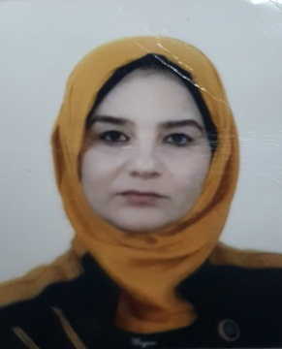
الاختصاص العام: علوم الحياة\ علم النبات
الاختصاص الدقيق: تصنيف النبات \ بيئة النبات
البريد الاليكتروني: mayasbio44@uomosul.edu.iq
الشهادة و اللقب العلمي : مدرس دكتور
عدد سنوات الخدمة : 19 سنة وعشرة اشهر
الباحث العلمي: May Taha
البوابة البحثية: May Taha Hamid Alwattar
رقم الباحث العلمي: 0000-0003-0504-7484
عدد البحوث المنشورة : 6
. Al-Nima,B.A. and Al-Wattar,M.T. 2018. The Invasive Potamogeton species in Tigris River Below Mosul Dam. LAP LAMBERT Academic Publishing.
Mohammad,A.S.,Al-Salih,H.S.and Al-Wattar,M.T.2002. The role of on of triazoles compounds as a new plant growth regulators in callus initiation and growth of Lactucasativa L. J. Of Iraqi Agr. Vol.(7) No.(5) p.78-98.
Mohammad,A.S.,Al-Salih,H.S.and Al-Wattar,M.T.2002. Effect of one of triazoles derivatives on protein content in Lactucasativa L. Sci. AL- Mustanseriia- Vol.(12) No.(7) p.719-728.

Al-Nima,B.A. and Al-Wattar,M.T..2011.Ecological study for invasive Potamogiton species in Tigris river stretch within Nineveh Province-Iraq.Swiss Federal Institute for forest ,snow and landscape research . WSL.zuercrestrsse III .8903.Birmensdrof,Switzerland.
Al-Wattar,M.T.and Al-Nima,B.A.2013. Primary study on macrohydrphytesan their environments in Tigris river below Mosul Dam . International J. Of Environment and water .vol. (2)Issue(4).

Al –Naib ,Amina Ismail and Al-Wattar ,May Taha 2021 .Molicular Taxonomy and genetic Diversity Evaluation among Seven Cultivars of Kalanchoe blossfeldina Poelln Using Random Amplified Polymorphic DNA(RAPD ) Markers. Plant Archives vol. Supplement1, pp.294-299.
Al wattar ,M.T. 2021 .Comparation of Oil Acids Content of Some of Apiaceae Family Genera by Gas Chromatography Technique. Egyptian Journal of Chemistry.vol.
References: (1) Judd et al. (2007) Plant Systematics: A phylogenetic approach, Third Edition. Sinauer Associates. (2) Laboratory Manual, available as a pdf from your instructors. (3) Optional: Castner, J. Photographic Atlas of Botany. (obtained through lab

