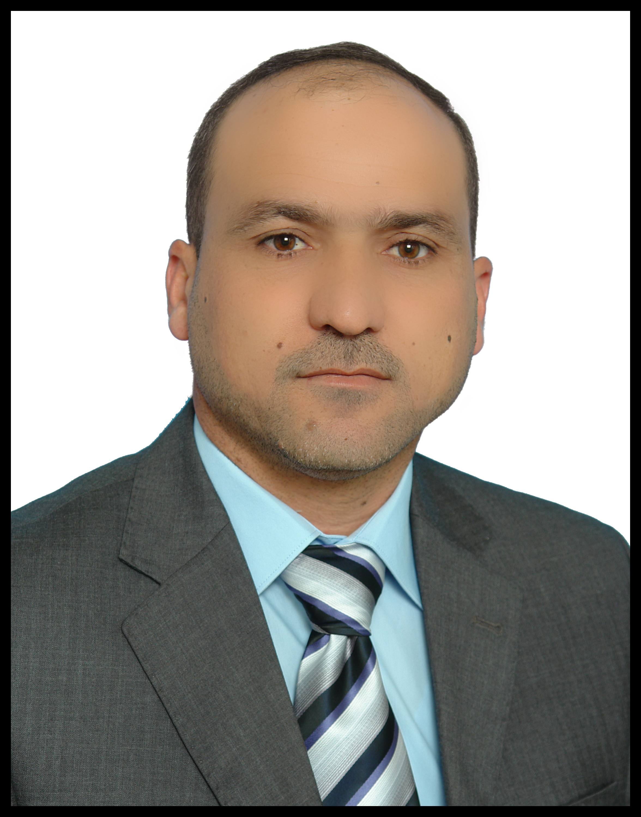
Dr Flyah Hassan Abass Al-Khatony
PhD in geochemistry

Profile
Flyah obtained a BSc from the University of Mosul, Iraq where he studied General Geology for four years. He finished his MSc in Geochemistry, 2003, During his studies, he worked on x-ray fluorescence, atomic absorption and spectrophotometers instruments . He joined the department of geology at the University of Mosul as an assistant lecturer, 2005, and he taught geochemistry, Exploration geochemistry & isotopes geology , crystallography and general geology .
Flyah started his PhD study at the University of Mosul in 2009. During his study, he worked on studying the geochemistry of arsenic in supergene systems and its environmental significance in Mosul and selected areas from north Iraq. He awarded his PhD from the University of Mosul in November 2014.
Affiliation:
Lecturer at the department of Geology, College of Science, University of Mosul, Iraq.
Education:
BSc General Geology, 2000, University of Mosul
MSc Geochemistry, 2003, University of Mosul
PhD in Geochemistry, 2014, University of Mosul

Conference:
First Geological Conference , 27 – 28th November, 2012 , College of Science / Kirkuk University . Iraq.

Publications:
- Aldabbagh, S.M. and Al-Khatony, F.H. (2008) : Environmental significance of Sedimentry Geochemistry of Manganese at selected areas from Iraq . Journal of Sharjah University for Pure Sciences , Vol.5, No.3.
- Aldabbagh, S.M. and Al-Khatony, F.H. (2010) : Sedimentry Geochemistry of Manganese in related to Parkinson Diseases (PD) at selected areas of Iraq . Medical Geology Newsletter . No,15
- Al-Khatony, F.H., Aldabbagh, S.M. and Alsabha, T.N. (2012) : The Chemistry of Rain Water in Relation to Dust Fall Over Mosul City and Al-Ba’aj Town / Northern Iraq. Journal of Environmental Studies. Article in Press. Received: 19 Jul, 2012. Accepted: 13 Oct, 2012.
Social Profiles
ResearchGate
https://www.researchgate.net/profile/ Flyah Alkhatony

